Caffe installation

This tutorial for caffe with CPU/GPU, no Python interface and ninja or shared libarary

**Collection links:**

1. Caffe window github branch: <https://codeload.github.com/BVLC/caffe/zip/windows>
2. Caffe window setub on github: <https://github.com/BVLC/caffe/tree/windows>
3. Link down cuda toolkit 8.0: <https://developer.nvidia.com/cuda-downloads>
4. Tutorial on installation caffe with cuda. <http://www.nvidia.com/object/caffe-installation.html>

How to install:

Step1. Install required softwares

* Visual studio 2013 or 2015
* CMake 3.4 or higher
  + When installing CMAKE, make sure that you select “add CMake to the system PATH

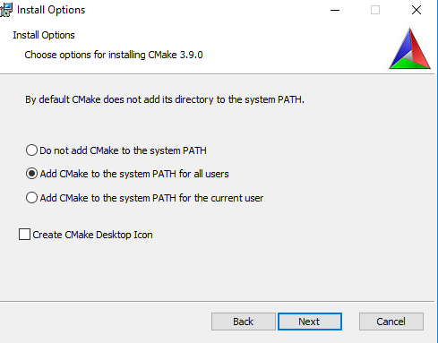

Optional Dependencies

* Python for the pycaffe interface. Anaconda Python 2.7 or 3.5 x64 (or Miniconda)
* Matlab for the matcaffe interface.
* CUDA 7.5 or 8.0 (use CUDA 8 if using Visual Studio 2015)
* cuDNN v5.1 for 8.0 CUDA toolkit
  + For CUDA toolkit, after installing it (the default folder will be “C:\Program Files\NVIDIA GPU Computing Toolkit\CUDA\v8.0”) , extract cuDNNv5.1 to this folder.

Step 2. Extract and copy the caffe-windows to your C\ folder.

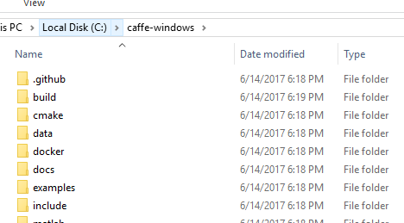

Step 3. Configure the build_docs.sh file in folder scripts.

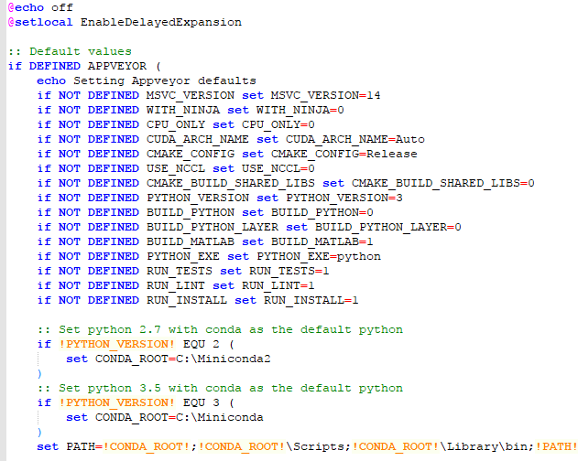

* Change MSVC_VERSION to the version that you use. Version 14 means Visual studio 2015.
* WITH_NINJA: do not use 🡪 set it to 0
* CUPU_ONLY: we are going to use GPU 🡪 set it to 0
* Python version: Version 3 is used in my case 🡪 set it to 3
* Python interface is bulded 🡪 set BUILD_PYTHON = 1.
* Matlab interface is used 🡪 set BUILD_MATLAB = 1
* Set the conda location of python. I used MIniconda installed at C:\Minniconda

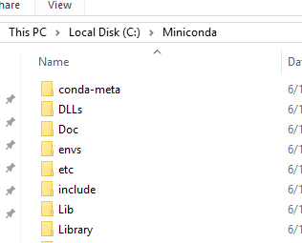

Also chaning this part in similar way

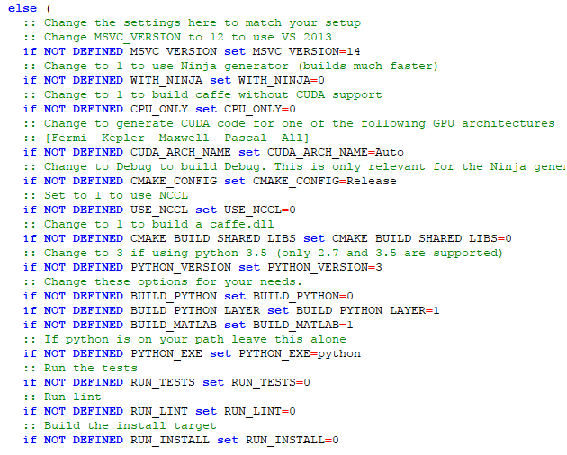

Step 4. Using cuDNN by adding location of cudnn

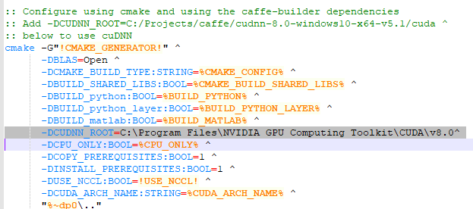

Here we use matlab for the interface, the c++ interface will be introduced latter.

Now running the build_win.cmd you might encounter the error of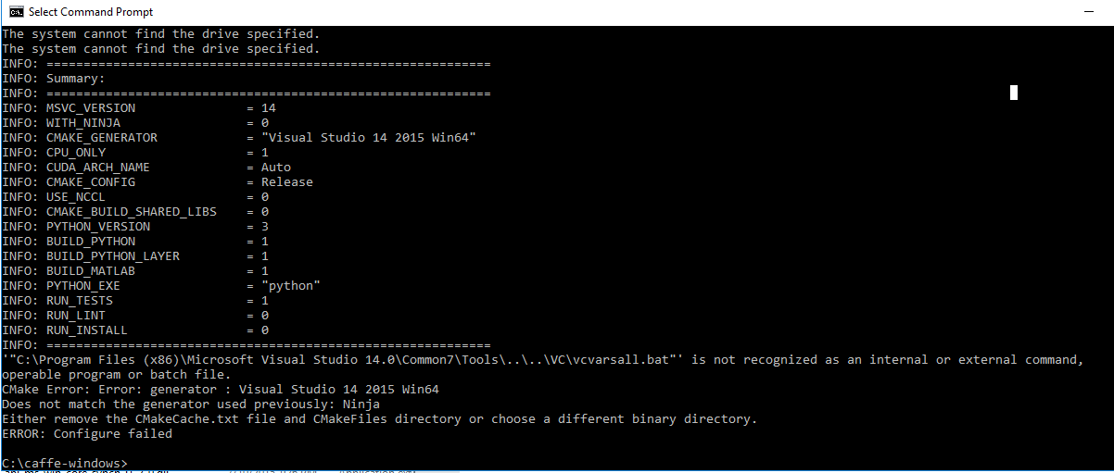

The error of cannot found vcvarsall.bat due to I did not install visual c++ in visual studio 2015 correctly. The solution is simple reinstalling visual studio or make sure you install viusal c++.

You also might face with the problem of cannot build shared library dll and we shold delete the cmakecache.txt. Then we can remove camake.txt and disable the dll shared library build at this time.

Here I am not install the python interface but matlab only.

After installing we will got this scenere with many warning (it is fine) and 0 error.

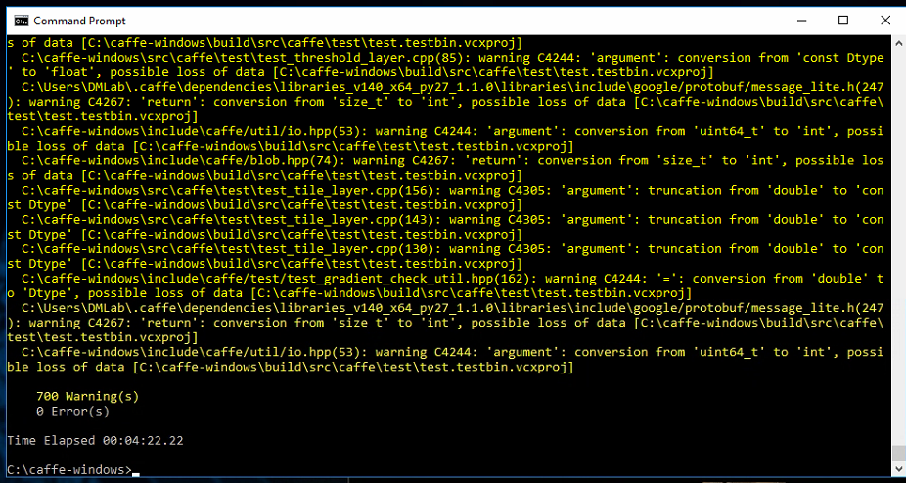

The previous figure show completed compile for CPU only. If you compile with GPU, there should be 1229 warnings and longer build time.

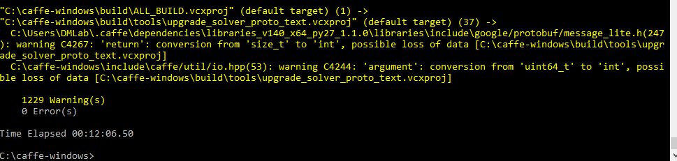

Now let try to run the sample code in matlab. The matlab example is located at “C:\caffe-windows\matlab\demo” with file name of “classification_demo.m”.

This time you will face with the problem of undefine ‘caffe_’ which caused by the location of mex file.

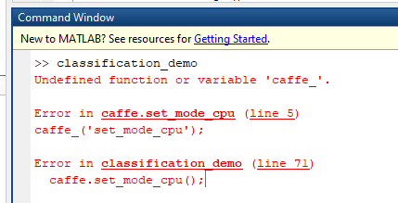

So, you should copy the caffe_.mexw64 from “C:\caffe-windows\matlab\+caffe\private\Release” to “C:\caffe-window\matlab\+caffe\private\”.

Then you need to download the file trained model of CaffeNet from the Model Zoo and put them to the “model” folder.

Then we can run example without any problem.

Python Interface

To install python interface, we should enable BUILD_PYTHON and PYTHON_VERSION as well as define their default location. In my case, I use python 2.7 with Miniconda2 so that I configure the file as follow

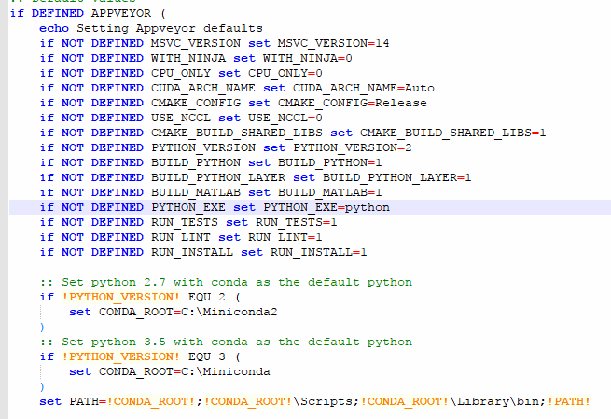

And

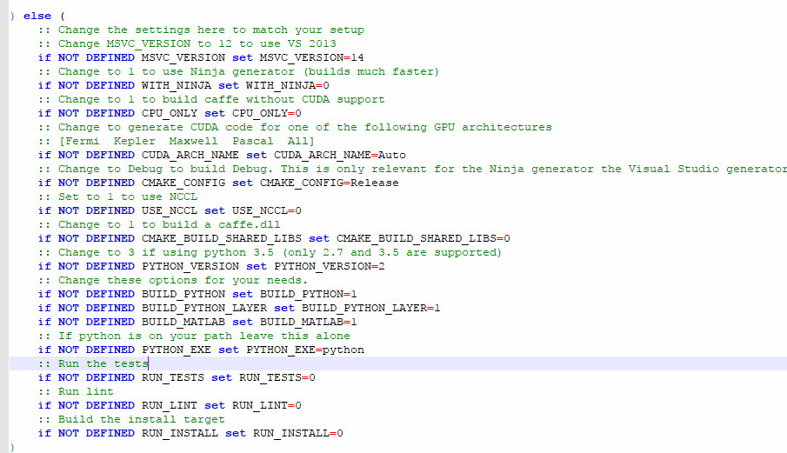

It should be noted that Caffe Window currently support python 3.5 only while the current python is 3.6. Be ware of this issues if you want to install python 3.x interface.

I also faced with problem of

**The dependency target “pycaffe” of target “pytest” does not exist.**

This is the problem of installing numpy. We can fix this problem by installing numpy in miniconda with

